Iview Tools User Manual

IrfanView is a tools to help you see the Raw8 format picture on windows.

1. **Install:**

**Step 1:**

Download the tar from our wiki and unzip it.There two exe in it.

daac8f576968a849b04f5102f4ffbaf

**Step 2:**

Click the iview453_x64_setup.exe to start installation.

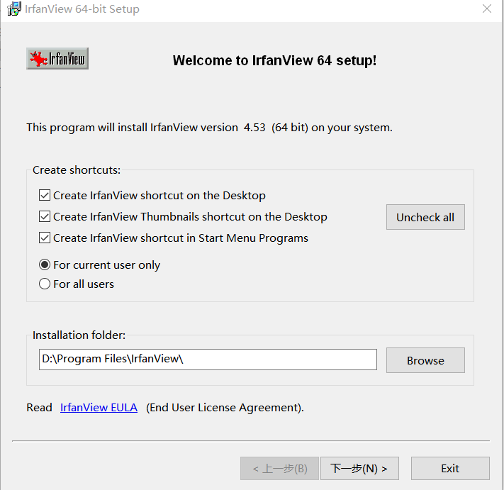

**Step 3:**

Click the iview453_plugins_x64_setup.exe to [install plug-in](D:/Program%20Files%20(x86)/Youdao/Dict/8.9.3.0/resultui/html/index.html" \l "/javascript:;).

1. **[Use](D:/Program%20Files%20(x86)/Youdao/Dict/8.9.3.0/resultui/html/index.html" \l "/javascript:;) [The](D:/Program%20Files%20(x86)/Youdao/Dict/8.9.3.0/resultui/html/index.html" \l "/javascript:;) [Tools](D:/Program%20Files%20(x86)/Youdao/Dict/8.9.3.0/resultui/html/index.html" \l "/javascript:;)**

Step 1:

Click the IrfanView 64 to start the tools.

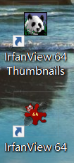

Step 2:

Open the file you want to see.

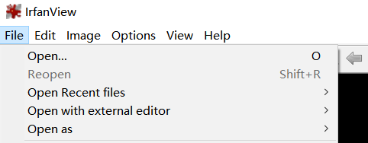

Step 3:

Set as below.

